Name: Ali Hassaan Mughal

Class: BSCS 6-B

Lab 2 Web Engineering

**Task 1**

<!DOCTYPE html>

<html>

<head>

<style>

ol

{

color:tomato;

}

ul

{

color:blue;

}

p

{

font-size: 15px;

color:red;

text-shadow: 0.5px 0.5px blue;

}

p:hover

{

font-size: 20px;

color:red;

text-shadow: 0.5px 0.5px blue;

}

body

{

background-color: white;

}

</style>

<title></title>

</head>

<body>

<p>There are two types of lists in HTML:</p>

<ol title="Types of Lists in HTML">

<li>Ordered List.</li>

<li>Unordered List</li>

</ol>

<p>List of Items in my Bag are:</p>

<ol title="List of Items in my Bag">

<li>Water Bottle</li>

<li>Watch</li>

<li>Books</li>

<li>Laptop</li>

<li>Charger</li>

</ol>

<p>Here is a list of my hostelmates</p>

<ul style="list-style-type:square" title="List of My Hostelmates">

<li>Momin Majid</li>

<li>Arbaz Khan</li>

<li>Asim Noor</li>

<li>Abdul Basit</li>

<li>Muhammad Uzair</li>

</ul>

<p>This is a nested unordered list of the websites I visit:</p>

<ul style="list-style-type:square" title="List of Websites I visit">

<li>Search:

<ul>

<li>Google Search Engine: <a href="http://google.com">http://www.google.com</a></li>

<li>Yahoo Search Engine <a href="http://yahoo.com">http://www.yahoo.com</a></li>

</ul>

</li>

</ul>

<ul>

<li>Specifications

<ul>

<li>Google search is most efficient: <a href="https://www.alexa.com/siteinfo/google.com">https://www.alexa.com/siteinfo/google.com</a></li>

<li>Yahoo is alternate in efficiency to google: <a href="https://www.alexa.com/siteinfo/yahoo.com">https://www.alexa.com/siteinfo/yahoo.com</a></li>

</ul>

</li>

</ul>

</body>

</html>

**Screenshot:**

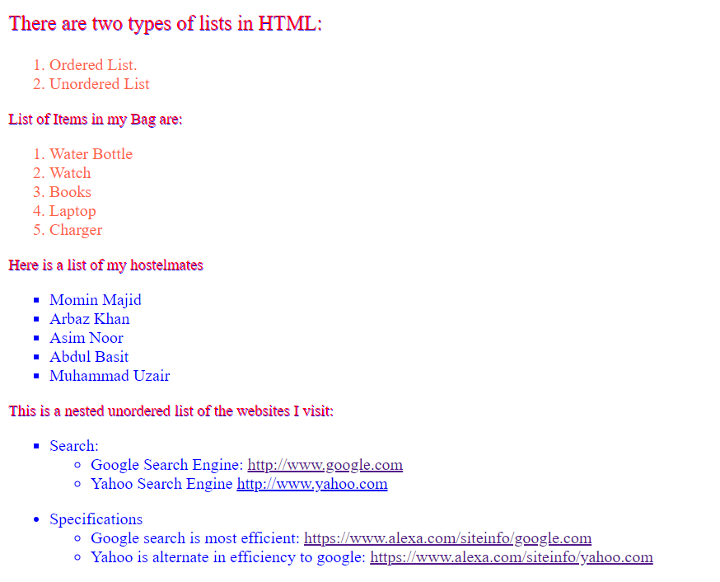

**Task 2**

<!DOCTYPE html>

<html>

<head>

<title></title>

</head>

<style>

th

{

height: 100px;

border-spacing: 10px;

border: 4px solid blue;

}

table, td {

border-spacing: 10px;

border: 1px solid black;

}

table

{

color: blue;

text-shadow: 0.5px 0.5px red;

width:100%;

height: auto;

}

</style>

<body>

<table>

<tr>

<th>Day</th><th>Subject</th><th>Time</th><th>Instructor</th>

</tr>

<tr>

<td rowspan="3">Monday</td>

<td>Web Engineering</td><td>11:00-11:50</td><td>Qaiser Riaz</td>

</tr>

<tr>

<td>Design of Algorithms</td><td>10:00-10:50</td><td>Sana Khalique</td>

</tr>

<tr>

<td>Probability & Statistics</td><td>14:00-14:50</td><td>Adnan Aslam</td>

</tr>

<tr>

<td rowspan="2">Tuesday</td><td>Computer Architecture & Organization</td><td>10:00-10:50</td><td>Nasir Mahmood</td>

</tr>

<tr>

<td>Web Engineering</td><td>14:00-14:50</td><td>Qaiser Riaz</td>

</tr>

<tr>

<td rowspan="2">Wednesday</td><td>Probability & Statistics</td><td>09:00-09:50</td><td>Adnan Aslam</td>

</tr>

<tr>

<td>Web Engineering</td><td>10:00-12:50</td><td>Qaiser Riaz</td>

</tr>

<tr>

<td rowspan="2">Thursday</td><td>Human Computer Interaction</td><td>14:00-15:50</td><td>Mehdi Hussain</td>

</tr>

<tr>

<td>Probability & Statistics</td><td>10:00-10:50</td><td>Adnan Aslam</td>

</tr>

<tr>

<td rowspan="2">Friday</td><td>Design & Analysis of Algorithms</td><td>11:00-11:50</td><td>Sana Khalique</td>

</tr>

<tr>

<td>Computer Architecture & Organization</td><td>14:15-16:50</td><td>Nasir Mahmood</td>

</tr>

</table>

</body>

</html>

**Screenshot**

